Improving Your Ally Score for Google Docs

Checklist for Improving your Ally score
While creating website content it is crucial to consider accessibility. There are a few basic steps that should be followed in order to assure your Ally score is increased:

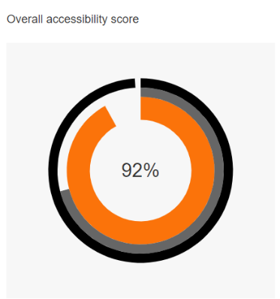
- Add built-in Headings to document and do not skip numbers (e.g. jumping from Heading 1 to Heading 3)
- Use built-in List options (e.g. bullets or numbers)
- Links should be descriptive text
- Add Alt Text for all images
- Define Table Headers and simplify Tables as much as possible
- Use the built-in accessibility checker

Helpful Information:
Blackboard WCM Accessibility Help
Make your document or presentation more accessible - Google Docs Editors Help

Sample Table:
Day of the Week | Start Time | End Time
Monday | 8:05 AM | 3:05 PM
Tuesday | 8:05 AM | 3:05 PM
Wednesday | 10:05 AM | 3:05 PM

This is Page 2

This is Page 3

